**OOP LAB 2 TASKS**

**Task 1:**

import java.util.Scanner;

public class Lab_2_task_1

{

public static void main(String[] args) {

int number = 10;

float price = 12.56f;

double length = 120.777;

char section = 'B';

boolean found = true;

String name = "Ansir Ali Qadri";

System.out.println("Integer: " +number);

System.out.println("Floating point Number: " +price);

System.out.println("Double: " +length);

System.out.println("Character: " +section);

System.out.println("Boolean: " +found);

System.out.println("String: " +name);

}

}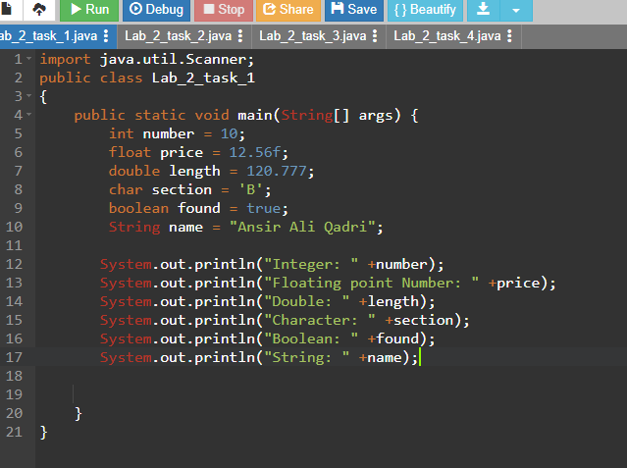

**Task 2:**

import java.util.Scanner;

public class Lab_2_task_2

{

public static void main(String[] args) {

int num1 = 14;

int num2 = 4;

System.out.println("Addition: " + (num1 + num2));

System.out.println("Subtraction: " + (num1 - num2));

System.out.println("Multiplication: " +(num1 * num2));

System.out.println("Division: " +(num1 / num2));

System.out.println("Modulus: " +(num1 % num2));

}

}

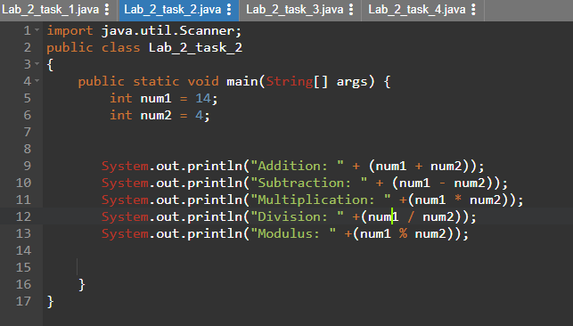

**Task 3:**

import java.util.Scanner;

public class Lab_2_task_3

{

public static void main(String[] args) {

int number = 12;

number += 2;

System.out.println("After += 2: " + number);

number -= 6;

System.out.println("After -= 6: " + number);

number *= 3;

System.out.println("After *= 3: " + number);

number /= 5;

System.out.println("After /= 5: " + number);

number %= 3;

System.out.println("After %= 3: " + number);

}

}

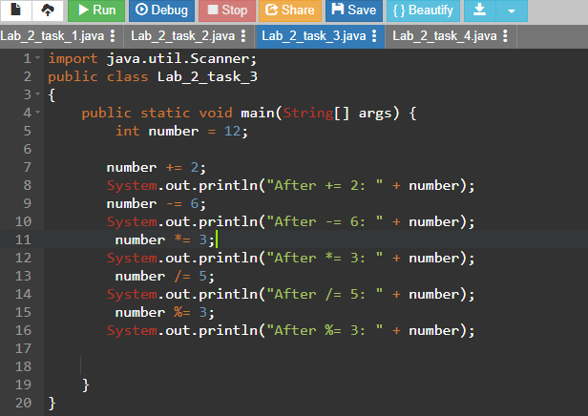

**Task 4:**

import java.util.Scanner;

public class Lab_2_task_4

{

public static void main(String[] args) {

int number = 18;

System.out.println("Original Value: " + number);

System.out.println("Post increment: " + (number++) );

System.out.println("After Post increment: " + number);

System.out.println("Pre increment: " + (++number) );

System.out.println("After Pre increment: " + number);

System.out.println("Post decrement: " + (number--) );

System.out.println("After Post decrement: " + number);

System.out.println("Pre decrement: " + (--number) );

System.out.println("After Pre decrement: " + number);

}

}

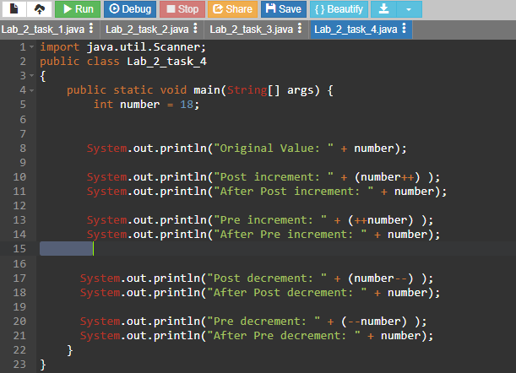

**Task 5:**

public class Lab_2_task_1

{

public static void main(String[] args) {

int number = 10;

if(number > 2){

System.out.println("The number is positive.");

}

else

{

System.out.println("The number is not positive.");

}

System.out.println("Statement outside if...else block");

}

}

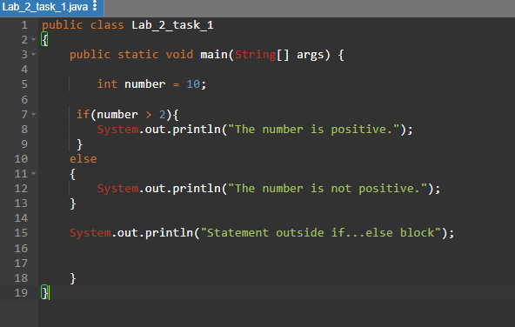

**Task 6:**

import java.util.Scanner;

public class Lab_2_task_6

{

public static void main(String[] args) {

int num1, num2, sum;

Scanner input = new Scanner(System.in);

System.out.println("Enter first number: ");

num1= input.nextInt();

System.out.println("Enter second number: ");

num2= input.nextInt();

sum = num1 + num2;

System.out.println("Sum is: " + sum);

}

}

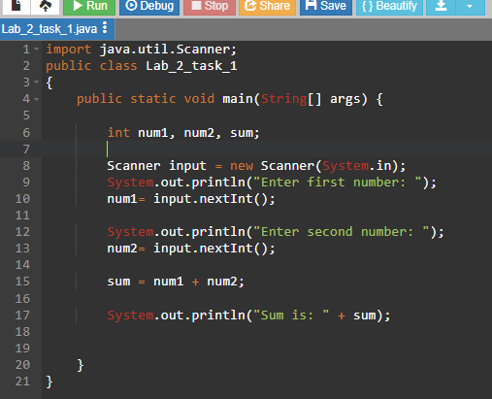

**Task 7:**

import java.util.Scanner;

public class Lab_2_task_7

{

public static int square(int num){

return num*num;

}

public static void main(String[] args) {

int result, number = 10;

result = square(number);

System.out.printf("square value of %d is: " ,number);

System.out.print(result);

}

}

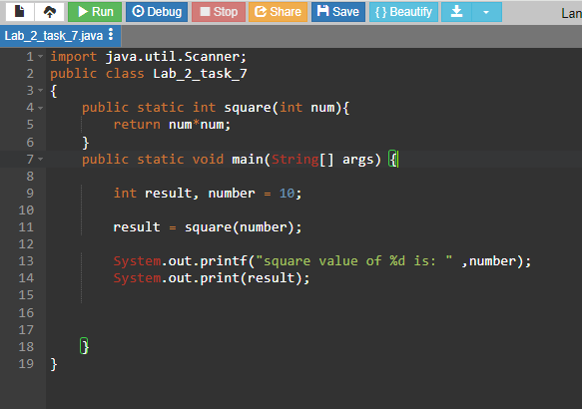

**Task 8:**

import java.util.Scanner;

public class Lab_2_task_7

{

public static